Discussion Assignment Unit 6
A hospital is upgrading its patient management system to ensure that real-time data from various medical devices (such as heart monitors, ventilators, and infusion pumps) is processed efficiently and reliably. The system must handle input from multiple devices and ensure that critical data is prioritized for timely action. To achieve this, the hospital is working with developers to enhance the I/O system and device drivers, ensuring optimal performance and reliability.
Based on the provided scenario, answer the following questions:
- How would the components of an I/O system manage simultaneous input data from multiple medical devices? What strategies would you use to prioritize critical data effectively?
To manage simultaneous input data from multiple medical devices, the I/O system must be designed to handle a high volume of data efficiently. Each medical device, such as heart monitors, ventilators, and infusion pumps, would be connected via a controller that interfaces with the main patient management system. The data from these devices would be transmitted through I/O ports and their respective registers, coordinated by a handshaking relationship between the host system and the device controllers. This ensures that each device’s input is recognized and processed (Silberschatz et al., 2013). To enhance efficiency, Direct Memory Access (DMA) controllers can be employed to transfer large data blocks directly to memory, thereby relieving the main CPU of the burden. This approach allows the CPU to focus on higher-level tasks, thereby maintaining system performance and reliability (Silberschatz et al., 2013). Figure 1 shows steps in a DMA transfer.
Figure 1
Steps in a DMA transfer.
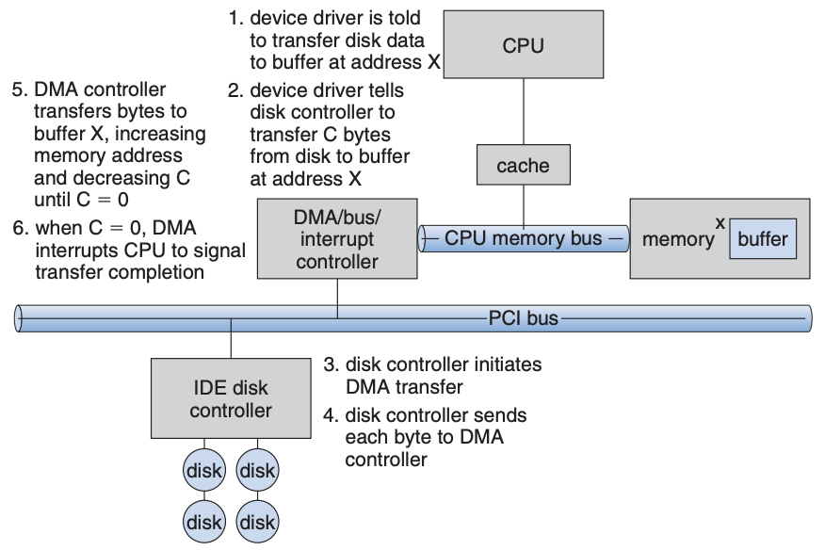

Steps in DMA transfer for efficient data processing
- Step 1: The device driver is instructed to transfer data from medical devices (such as heart monitors, ventilators, and infusion pumps) to the buffer at a designated memory address.
- Step 2: The device driver communicates with the disk controller to transfer a specified number of bytes from the medical devices to the buffer at the given memory address.
- Step 3: The disk controller initiates the DMA transfer, setting in motion the direct transfer of data blocks.
- Step 4: The disk controller sends each byte of data to the DMA controller, which manages the transfer process.
- Step 5: The DMA controller transfers the bytes to the buffer, incrementing the memory address and decrementing the byte count until all data is transferred.
- Step 6: Once the transfer is complete (when the byte count reaches zero), the DMA controller interrupts the CPU to signal the completion, allowing the CPU to focus on higher-level tasks and maintain system performance and reliability.
By employing DMA for transferring large data blocks directly to memory, the hospital can ensure that the main CPU is relieved of the burden of handling data from multiple medical devices. This approach allows the CPU to prioritize critical tasks and maintain system performance and reliability, ensuring timely action on patient data.
Prioritizing critical data effectively is paramount in a medical setting where timely action can be life-saving. One strategy to achieve this is through interrupt-driven I/O. Each medical device would generate interrupts to signal the CPU when data is ready for processing. By assigning higher interrupt priority levels to critical devices, such as heart monitors, the system ensures that these devices receive immediate attention. The interrupt vector table would be configured to distinguish between high-priority and low-priority interrupts, enabling the CPU to respond appropriately based on urgency (Silberschatz et al., 2013). Vectored interrupts combined with interrupt chaining can further optimize this process by efficiently dispatching the relevant interrupt handlers (Silberschatz et al., 2013). This ensures minimal delay in processing critical data, enhancing the responsiveness of the patient management system.
To further improve performance and reliability, the hospital could implement multilevel interrupts to manage varying degrees of urgency. During critical processing periods, the system can defer handling of lower-priority interrupts, focusing on high-priority tasks such as monitoring vital signs. Additionally, employing sophisticated interrupt-handling features within the operating system allows the hospital to manage hardware faults and software exceptions efficiently (Silberschatz et al., 2013). For instance, the system can handle page faults and execute privileged routines in kernel mode with minimal disruption. According to Silberschatz et al. (2013), regular updates to device drivers and continuous monitoring of system performance would be essential to maintain optimal functionality. These strategies collectively ensure that the patient management system processes real-time data accurately, prioritizing critical inputs to safeguard patient health.
- Explain the role of device drivers in upgrading the hospital's system. What potential challenges could occur when integrating multiple device drivers into a unified system?
Device drivers play a crucial role in upgrading the hospital's patient management system by creating a bridge between various medical devices and the operating system. Each medical device, such as heart monitors, ventilators, and infusion pumps, operates with its unique interface and communication protocols. The device drivers encapsulate the specific interactions required for each medical device, allowing the patient management system to communicate efficiently with them (Arpaci-Dusseau & Arpaci-Dusseau, 2018). For instance, the heart monitor driver would be responsible for handling the specific signals transmitted by the monitor, while the ventilator driver would manage its distinct operational requirements. By utilizing device drivers, the hospital ensures that the inputs from all medical devices can be integrated into a single, coherent system, allowing real-time data processing that prioritizes critical information essential for patient care.
However, integrating multiple device drivers into a unified system presents several challenges. One of the primary risks is ensuring compatibility between the various drivers, particularly if they have differing performance metrics or data formats (Arpaci-Dusseau & Arpaci-Dusseau, 2018). For example, if the driver for the infusion pump communicates data at a slower rate compared to the heart monitor driver, it may create latency in data processing, potentially compromising timely interventions during emergencies. Additionally, the complexity of managing multiple drivers can result in increased system overhead, leading to reliability issues. Moreover, since device drivers may be developed by different teams or vendors, the potential for bugs and inconsistencies can intensify (Arpaci-Dusseau & Arpaci-Dusseau, 2018), further complicating integration efforts and affecting the overall performance of the patient management system.
To address these challenges effectively, developers must focus on creating a robust I/O system that ensures seamless communication among device drivers. This may involve standardizing data formats across the various medical devices, thereby minimizing discrepancies during data transfer (Arpaci-Dusseau & Arpaci-Dusseau, 2018). For example, using a unified protocol for both the heart monitor and the ventilator can help streamline communication and enhance data accuracy. Additionally, implementing rigorous testing and validation processes for each device driver before full integration can help identify and resolve compatibility issues early on. Such proactive measures will ultimately facilitate a more efficient, reliable, and responsive patient management system (Arpaci-Dusseau & Arpaci-Dusseau, 2018), allowing healthcare professionals to act quickly on critical patient data generated from multiple medical devices.
References
Silberschatz, A., Galvin, P., & Gagne, G. (2013). Operating system concepts essentials (2nd ed.). John Wiley & Sons, Inc
Arpaci-Dusseau, R. H., & Arpaci-Dusseau, A. C. (2018). Operating systems: three easy pieces (1.01 ed.). Arpaci-Dusseau Books. https://pages.cs.wisc.edu/~remzi/OSTEP/

